User story

1. As a student, I want to make cashless payment (e.g. TNG e Wallet, Boost) so that the payment is simple and easy.
2. As a student, I want to have discount on books so that I can save money.
3. As a student, I want to search a book so that it can link me to the page and the book I wanted easily.
4. As a student, I want to have a page that collect my wish list so that I can collect all the items that I want before decide to buy it.
5. As a student, I want to have an update on information for new books in daily basis so that I can get the new published books’ information.
6. As a student, I want my privacy is encrypted so that no one’s able to access my information.
7. As a student, I want to contact seller so that I can inquiry for the details (e.g. books details, shipping status).
8. As a student, I want to sell my preloved and unused books so that I can earn extra income.
9. As a student, I want to chat in the forums so that I able to ask questions and know more about the authors’, books’ and reviewers’ information.
10. As a student, I want to trade in books so that I able to explore knowledge in different books with minimum amount of cost.
11. As a student, I want to compare the prices of book with other book trading website prior purchase so that I can get the book with lowest costs.

User story mapping

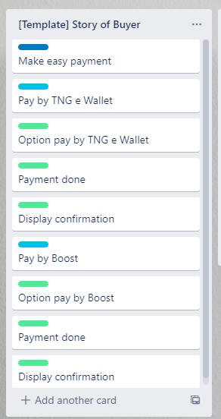

User story 1

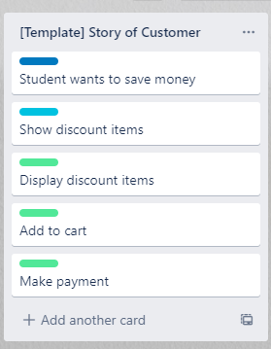

User story 2

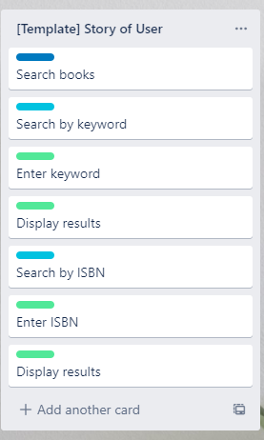

User story 3

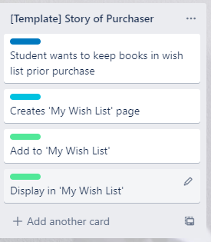

User story 4

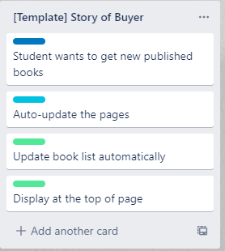

User story 5

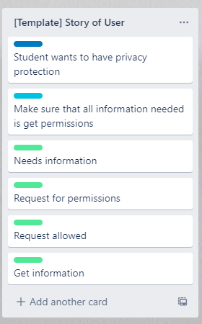

User story 6

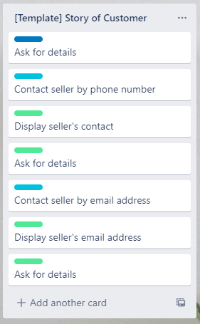

User story 7

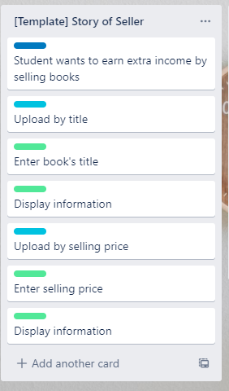

User story 8

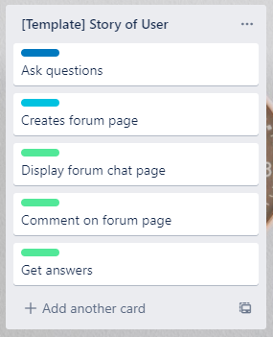

User story 9

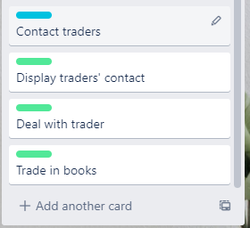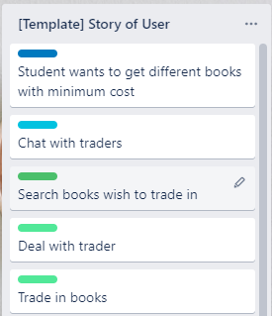

User story 10

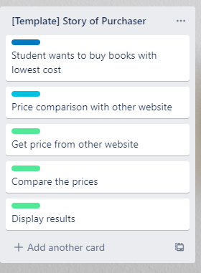

User story 11

<https://trello.com/b/DbXNo9oO/user-story-mapping-book-trading-system>